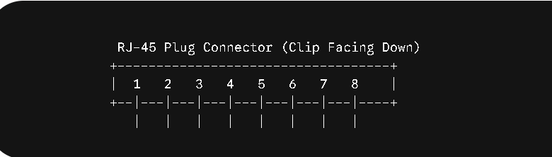

Pin # | Signal Pair (10/100) | T568A Wire Color | T568B Wire Color
1 | Transmit+ (Tx+) | White-Green | White-Orange
2 | Transmit- (Tx-) | Green | Orange
3 | Receive+ (Rx+) | White-Orange | White-Green
4 | Reserved / Bi-directional | Blue | Blue
5 | Reserved / Bi-directional | White-Blue | White-Blue
6 | Receive- (Rx-) | Orange | Green
7 | Reserved / Bi-directional | White-Brown | White-Brown
8 | Reserved / Bi-directional | Brown | Brown
2. Ethernet Standards Comparison
Specification | 10BASE-T | 100BASE-TX | 1000BASE-T
Data Transfer Rate | 10 Mbps | 100 Mbps (Fast Ethernet) | 1 Gbps (Gigabit Ethernet)
Cable Type | Cat3 or Cat5 UTP | Cat5 or Cat5e UTP | Cat5e or Cat6 UTP
Max Cable Distance | 100 meters (328 ft) | 100 meters (328 ft) | 100 meters (328 ft)
Connector Type | RJ-45 | RJ-45 | RJ-45
3. Direct Laptop-to-Laptop Connection
To connect two laptops directly without a switch or hub, a Crossover Cable is traditionally required.
- Reasoning: Laptops are host devices (DTEs) that send data on pins 1 & 2 (Transmit) and listen for data on pins 3 & 6 (Receive). A straight-through cable maps pin 1 to pin 1, causing both laptops to transmit onto the same lines and listen on dead lines. A crossover cable swaps pins 1 & 2 with pins 3 & 6 on one end, routing Laptop A’s transmit pins directly into Laptop B’s receive pins.
- Modern Note: Almost all contemporary laptop network cards feature Auto-MDI/MDIX, a feature that automatically detects the connection type and swaps the Tx/Rx pairs electronically, allowing standard straight-through cables to function identically in modern setups.
4. Real-World Ethernet Devices
- Desktop Computer (College Lab): Uses 1000BASE-T (Gigabit Ethernet) via Cat6 cabling to support heavy data transfers, central server logins, and rapid ISO downloads.
- Wi-Fi Router (Home Gateway): Uses 1000BASE-T on its WAN/LAN ports to match incoming gigabit fiber broadband throughput and prevent internal network bottlenecks.
- Smart TV or IP Network Printer: Uses 100BASE-TX (Fast Ethernet), as 100 Mbps provides more than enough dedicated bandwidth for smooth 4K video streams (~25 Mbps requirement) or print queue spooling.

